Target Abstraction Layer
Porting Guide
Copyright © 2026, Imagination Technologies Ltd. All Rights Reserved.
This publication contains proprietary information which is protected by copyright. The information contained in this publication is subject to change without notice and is supplied 'as is' without warranty of any kind. Imagination Technologies and the Imagination Technologies logo are trademarks or registered trademarks of Imagination Technologies Limited. All other logos, products, trademarks and registered trademarks are the property of their respective owners.
Filename : 0000.doc
Version : 1.0.2 Not Issued - Live Document
Issue Date : 21 Sep 2012
Author : Imagination Technologies
Contents
1. Introduction 4
1.1. Definitions 4
2. Overview 5
2.1. Test Targets 5
2.2. Tests 5
2.3. Target Abstraction Layer (TAL) API 5
2.4. Target API 5
2.5. Wrapper API 5
2.6. PDUMP API 6
2.7. Test Agent 6
2.8. PDUMP Player 6
3. TAL Implementations 7
3.1. “Normal” TAL 7
3.2. “Light” TAL 7
3.3. “Portability Framework” TAL 7
4. Target Abstraction Layer (TAL) API 8
4.1. Overview 8
4.2. Error Handling 8
4.3. Memory Spaces 8
4.4. Memory Space Names and Memory Space IDs 8
4.5. Interrupt IDs 8
4.6. Address Mangling 8
4.7. Check Functions 8
4.8. Device Memory 9
4.9. PDUMP Capture 9
5. Porting the Target Abstraction Layer (TAL) 10

IF{{Internal}}
$Revision: 1.3 $
Document History
Issue | Date | Changes/Comments
0.1.1a | 04 Feb 2004 | First Version.
1.0.3 | 27 Feb 2009 | External Issue
END{{Internal}}

Introduction
This document provides a guide to porting the Target Abstraction Layer (TAL). The guide is designed as a generic document and may be include within any software packages that uses the Target Abstraction Layer and that may require the user to port the driver or API to a new platform.
The TAL is designed to abstract the interface between the driver, API or test applications and the target device (block of IP). All register and memory accesses relating to the target device pass through the TAL and can be captured as a PDUMP script and/or routed to the instantiation of the target device which may be:
- a software simulator
- an rtl simulation
- rtl running on an FPGA system
- the final rtl embodied within an SoC

Definitions

Device
A part of a device (block of IP) that can be embodied in a variety of ways
Host
The platform on which the test application or drivers are run
Target
The platform or platforms on which the devices under test can be instantiated
Tests
Test applications, drivers and associated data.

Overview
The diagram below should the basic components of the system:

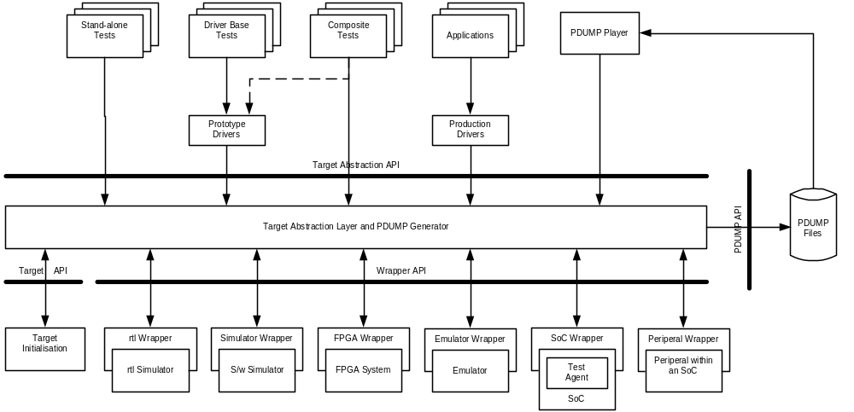

Test Targets
As can be seen from the diagram a variety of targets exist on which tests can be run.
The targets include:
- the rtl block running on a simulator
- the software simulator of the IP block
- an FPGA system containing an image of the rtl block
- the emulator containing an image of the rtl block
- the final SoC
Note: This list is not an exhaustive list, but represents the more general cases. For example, on other projects a player has been implemented that runs on the embedded processor during rtl simulations.

Tests
Test can be stand-alone, base on the use of a prototype driver or can use the driver for some functions but may require access to register in order to setup a mode or setting not supported by the driver.

Target Abstraction Layer (TAL) API
The TAL API abstracts register and memory access relating to the parameters and control of the device.
The PDUMP Generator can be used to generate PDUMP output corresponding to these accesses.

Target API
The Target API allows the devices to be registered with the TAL.

Wrapper API
The Wrapper API is designed to present a common interface to the devices below the TAL.

PDUMP API
The PUMP API abstracts the PDUMP output routines to enable memory base storage of PDUMP data on embedded systems.

Test Agent
On SoC containing an embedded processor, the Test Agent is a small software agent that performs memory and register operations on the target on behalf of the wrapper.

PDUMP Player
Is a program that can be used to replay PDUMP2 scripts. It uses the Target Abstraction Layer APIs so that it can be used to drive any target supporting the Wrapper API.

TAL Implementations
There are currently three implementations of the TAL API; the “normal”, “light” and “Portability Framework” TAL. The functionality varies according to the target environment.

“Normal” TAL
The “normal” implementation provides the means of capturing parameters as PDUMP scripts. The primary use of this implementation is under Windows when development the drivers or APIs and test applications. The “normal” version of the TAL can be found in:

<package>\target\libraries\tal\normal\code

“Light” TAL
The “light” implementation is for use in Meta systems (Meta is the processor designed and developed by the Metagence Division of IMG). This implements the TAL APIs, but register read/writes are through simple memory mapped accesses to the device. The device memory functions are mostly stubs, although the implementation does handle the virtual to physical address translation via the CPU’s MMU. The “light” implementation does not implement the PDUMP capabilities or the Wrapper API. The primary use of this implementation is for Meta based systems typically running MeOS or Nucleus.
The “light” version of the TAL can be found in:

<package>\msvdx_apis\target\libraries\tal\light\code

“Portability Framework” TAL
The “Portability Framework” implementation is in systems where the Portability Framework is used – normally non-embedded system such as Linux, Symbian, WinCE etc. – systems that have a user / kernel mode split. For OSs with a user / kernel mode split the Portability Framework provides an OS agnostic environment for the development of the kernel mode device drivers and kernel mode components, and a kernel mode OS abstraction layer. For non-embedded DDKs, details of the Portability Framework can be found in “Portability Framework.Overview” – this will not be included in embedded DDK packages.
The “Portability Framework” version of the TAL can be found in:

<package>\msvdx_apis\target\libraries\tal\port_fwrk\code

Target Abstraction Layer (TAL) API

Overview
The following section describes the some of the key features of the TAL.

Error Handling
In general, asserts are used to trap and report errors detected by the TAL. This removed the need for the driver, API or test program to check the return value. This includes unexpected error reported by the underlying layers. In the event that the returned value is other than IMG_SUCCESS then this will be an event that the user should expect and will be clearly documented as a possible return value from the TAL function.

Memory Spaces
Devices are assumed to have one or more memory spaces, which might include:
- Device registers
- The devices view of system memory (which may be different from the processors view)
- Device slave ports

Memory Space Names and Memory Space IDs
The memory spaces are “named”. There is a TAL function used to convert the name into a memory space ID, which is used in the majority of the remaining TAL functions. The names are made known to the TAL when the memory space is register with the TAL from the TARGET_Initialise function.

Interrupt IDs
Where a device/block has more than one interrupt line then the interrupt ID is used to identify which interrupt is being referenced.

Address Mangling
Address mangers are use to modify a memory address before it is written. Address mangling may be needed:
- When the devices view of memory is different from the processors view
- When the address needs to be modified before it is written (e.g. shifted by some amount)
The mangling functions are normally located below the Wrapper API. There are referred to by name and will appear in the PDUMP2 scripts as a function to be applied to the address and offset.
If the TAL implementation does not implement the Wrapper API then the address mangling handling is implemented within the TAL.

Check Functions
For polling, check functions are required to perform the necessary shifts, masking, logical and comparison operations to determine whether an event has occurred.
The check functions are normally located below the Wrapper API. There are referred to by name and will appear in the PDUMP2 scripts as a function to be applied to the value to be written.
If the TAL implementation does not implement the Wrapper API then the check functions handling is implemented within the TAL.

Device Memory
In non-unified memory systems then the device’s view/mapping of memory may differ from the host or CPU’s view. In order to record memory based parameters the TAL provides functions for allocating, manipulating and referencing device memory. This relies on the test application or driver using these functions to record the accesses to device memory:
- The test/drive will allocate a buffer or block of memory that contains data that is to be accessed by the device.
- A block of device memory is allocated via the TAL and the device memory updated via the TAL (this will copy the contents of the test/driver buffer to the device memory).
- The device will then be enabled and will operate of the data it has been passed.
- Having completed the operation the test/driver can view any changes to the buffer by using the TAL to copy the device memory “back” to the host.
It is the test application or drivers responsibility to use the TAL to copy data to/from device memory when the contents have changed or been updated by either the host or device.
In a unified memory system the device memory function are not needed and become stubs. However, because the TAL “knows” when an address is being written to a register to memory then the TAL functions can perform the appropriate virtual to physical address translation.

PDUMP Capture
The full TAL implementation contains a means of capturing PDUMP parameters, scripts and control information. The captured data can be used in rtl testing etc.

Porting the Target Abstraction Layer (TAL)
NOTE: If the package you are using uses the Portability Framework then you should not need to port the TAL the “Portability Framework” version should be appropriate for most applications.

Porting of the TAL involves the development of a TAL implementation for your platform. More than likely this will be based on the “light” implementation (see“Light” TAL ). You should follow the following steps:
- Before starting it is recommended that you first build and link the drivers or APIs from IMG that use the TAL in order to determine the sub-set of TAL functions referenced by the drivers or APIs – these will be listed as undefined functions and are the sub-set of the TAL functions you need to implement
- Create a copy of the appropriate version of the TAL and remove any functions not referenced by the drivers or APIs
- Modify the code to provide the require functionality but implement for your platform
- Create a simple test application to test you TAL implementation – starting with basic register accesses and progressing to the more complex functions
- Build and test your implementation with the drivers or APIs.

